**Name: Chipinapi Karthik**

**Rig.no:23BCE20022**

**1.** **Python program to find whether the given number is Even or Odd**

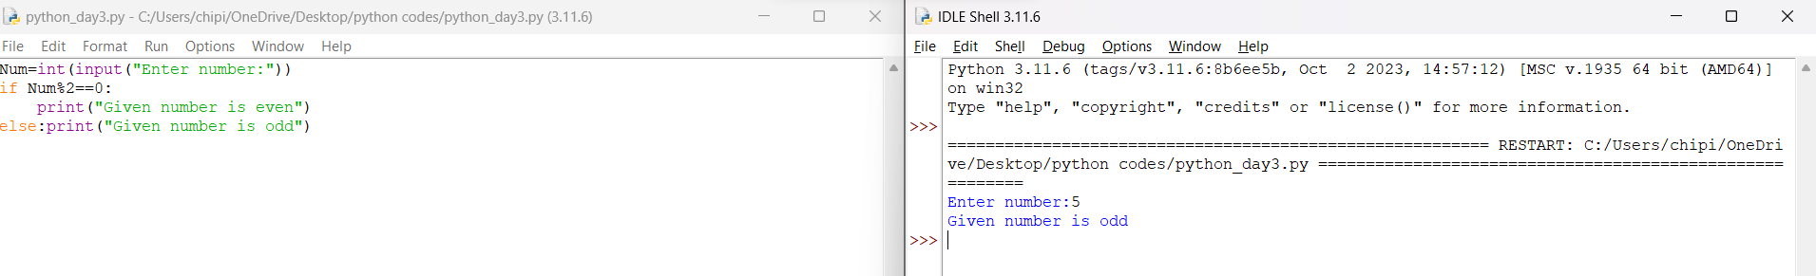

**2.** **Write a Python program to get the difference between a given number and 17, if the number is greater than 17 return double the absolute difference**

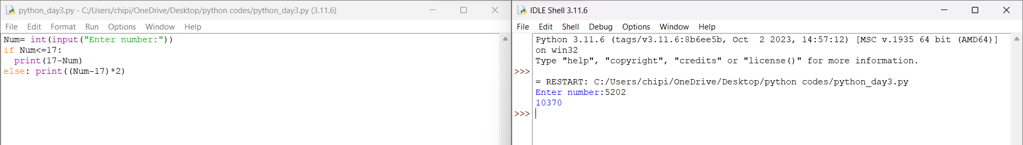

**3.Write a Python program to test whether a number is within 100 of 1000 or 2000.**

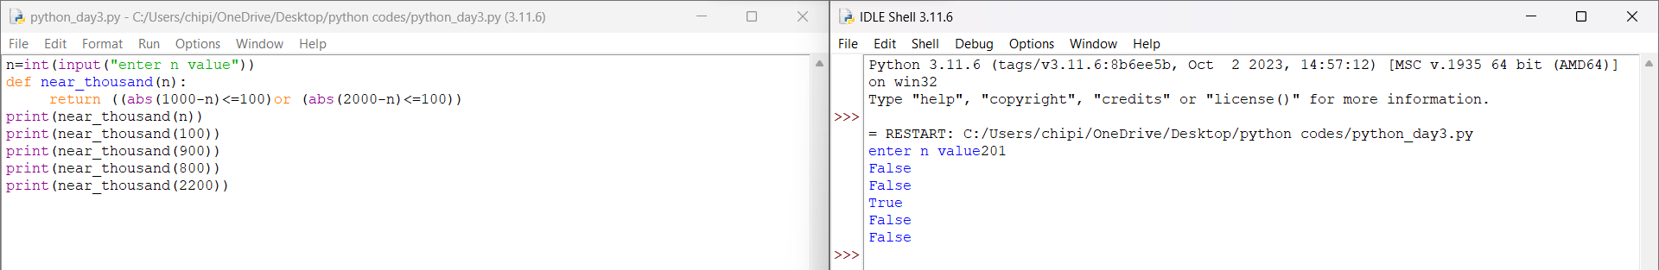**4.Write a Python program to calculate the sum of three given numbers, if the values are equal then return three times of their sum**

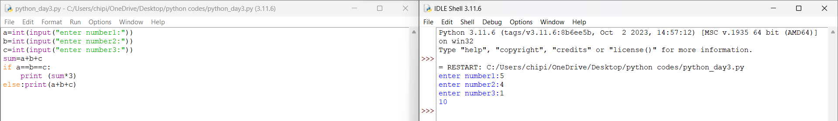

**5.Python Program to Find the Factorial of a Number**

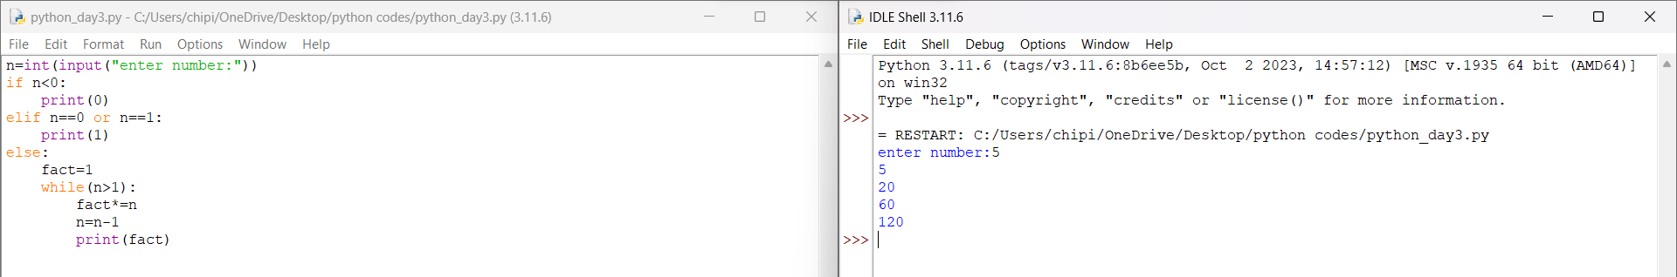**6.Python Program to print maximum of 3 numbers**

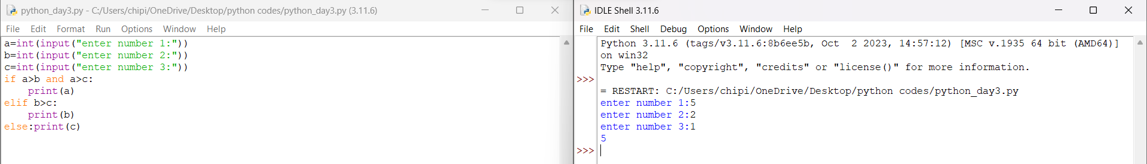**7.** **Write a python program to find whether a given year is leap or not.**

